Academic visit to Institute for Plasma Research, Gandhinagar

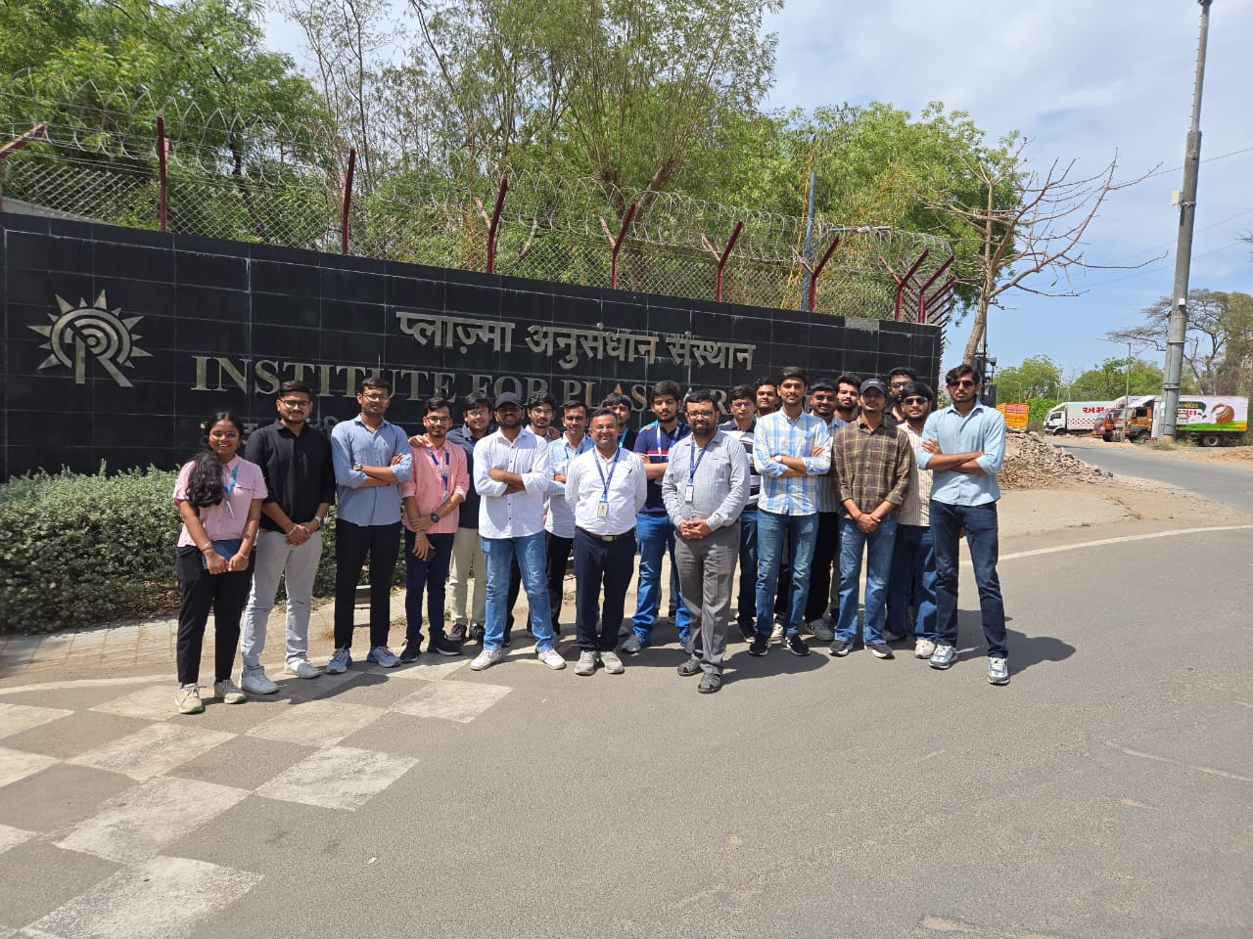

CHAMOS Matrusantha Department of Mechanical Engineering organized an enriching industrial visit to Institute for Plasma Research, Gandhinagar on March 25, 2026, for third-year B. Tech Mechanical students. A total of 28 students participated in this academic visit aimed at enhancing their practical understanding of advanced technologies. During the visit, students were introduced to the fundamentals of plasma science, fusion technology, and various state-of-the-art research facilities. The exposure helped bridge the gap between theoretical concepts and real-world applications, fostering curiosity and research-oriented thinking among the participants. The visit proved to be highly informative and aligned with the institute’s commitment to delivering quality education through experiential learning.

